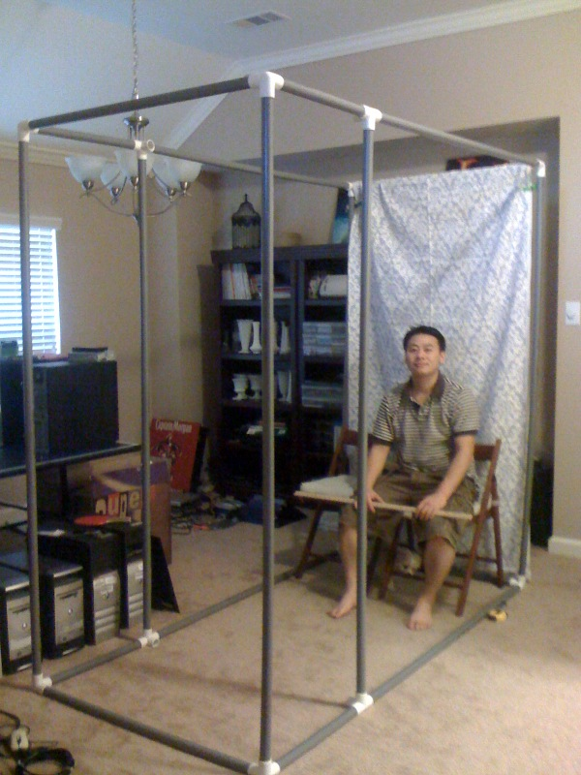

Pieces Required (I used electrical conduit because it was grey):

4 x 12” pieces

6 x 39” pieces (if you use white PVC, then you can do 40” to be even)

(Also… in the picture I am missing 2 pieces.)

4 x 60” pieces

6 x 78” pieces

60”

12”

78”

39”